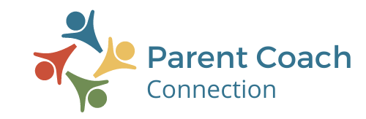
MACMH 2022
Handout ©JI Consults from How Much Is Too Much Leaders Guide by Jean Illsley Clarke.
Permission to reproduce for educational purposes.


My

MY HIGHWAY
You can
think before you say yes or no and learn from your mistakes.

Adults- Recyling 6-12 Year Olds
Adult’s
Temperament
Health

Situation

JOBS OF THE ADULT
• Continue to learn skills, learn from mistakes, and decide to be adequate.
• Expand ability to listen and look in order to collect information and think.
• Expand one’s own intuitive abilities.
• Reason about wants and needs as we teach children the difference.
• Evaluate family rules and learn more about structures outside the family.
• To examine the relevancy of old personal and family rules.
• Be willing to accept the consequences of breaking rules without whining or blaming.
• Improve skills for disagreeing with others and still be able to stay connected with them.
• To test ideas and values and learn value options beyond the family and one’s own culture.
• Examine internal controls and be sure they are helping you accomplish what you want from your life.
• Learn what is one’s own responsibility and what is the responsibility of others and set appropriate boundaries.
• Choose when to test abilities against others, when against standards or when against self.
.
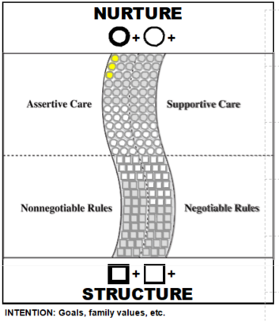

You can
trust your
intuition to
help you
decide what
to do.

I love you
even when
we differ;
I love
growing
with you.

You can
think for
yourself and
get help
instead of
staying
in distress.

You can learn when and how to disagree
You can
learn the rules that help you live with others.

You can
find a way of doing things that works for you
Handout ©JI Consults from How Much Is Too Much Leaders Guide by Jean Illsley Clarke.
Permission to reproduce for educational purposes.

For more information please contact Lisa Krause lisa@parentcoachconnection.com
763-438-1093
www.parentcoachconnection.com

